Problem Statement:

Write a program that implements a complete topology design problem. Given a collection of customer sites and a list of concentrators' locations, find the chosen concentrators, and sites connected to each of them to minimize the cost.

Notes:
- No graphical interface is required.
- BONUS marks are given for finding all the minimum concentrator assignments.

Input form:
  - Insert the number of sites
  - Insert the number of concentrators
  - Insert the maximum number of sites that cam be connected to each concentrator (K.)
  - Write a path of file that contains the cost matrix Cij which is the cost of connecting customer site i to concentrator j, followed by the cost of each concentrator like next one:

 | 0 | 1 | 2 | 3 | 4
1 | 1 | 6 | 7 | 9 | 2
2 | 4 | 5 | 7 | 9 | 0
3 | 3 | 7 | 5 | 8 | 9
4 | 0 | 7 | 9 | 6 | 5
 | 0 | 0 | 0 | 0 | 0

In previous example we have four sites and five concentrators and the cost of each concentrator is Zero. For example the cost of connecting site 3 to concentrator 2 is 5.

Note: the only written items in the file are the entries only like that

1 | 6 | 7 | 9 | 2
4 | 5 | 7 | 9 | 0
3 | 7 | 5 | 8 | 9
0 | 7 | 9 | 6 | 5
0 | 0 | 0 | 0 | 0

Output form:

- The used concentrators.
- Each sites followed by the concentrator that it connected to it.
 | Solution
For site 1 | C0
For site 2 | C1
For site 3 | C0
.
.
.
For site n | Cx

The assignment equivalent to the solution is shown in form like that:

The used concentrators are | C0 | C1 | …. | Cx

Data Structure:

- Dynamic arrays used to store the outputs and the inputs
  - 2D array to store cost matrix Cij
  - 1D array to store the cost of each concentrator
  - 1D array to store the solution
  - 1D array to store the assignment of concentrators that given minimum cost.

Algorithms:
    - Get Initial Solution using minimal possible number of Concentrators:
      - For each combination of minimal possible number of Concentrators which given by divide number of sites / K get the optimal solution of that combination of concentrator and store the minimal combination in the end.
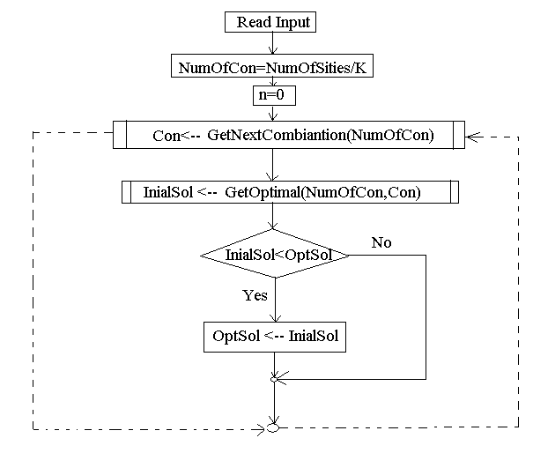
    - Get Next combination method (next_combination( n_begin:integer, n_end : integer , r_begin : integer , r_end : intger))

- N and r are represented by vectors and this method take the begin and end of each vector for example let n = 6 and r =4.
- All the objects in the n sequence must be distinct.
- For next_combination(),the r sequence must be initialised to the first r-th elements of n sequence in the first call. For example, to find combinations of r=4 out of n=6 {1,2,3,4,5,6}, the r sequence must be initialsed to {1,2,3,4} before the first call.
- As for prev_combination(), the r sequence must be initialised to the last r-th elements of n sequence in the first call. For example, to find combinations of r=4 out of n=6 {1,2,3,4,5,6}, the r sequence must be initialsed to {3,4,5,6} before the first call.
- The n sequence must not change thoughout the process of finding all the combinations; otherwise, results are wrong (makes sense, right?).
- next_combination() and prev_combination() operate on data types with the == operator defined. That means that if you want to use next_combination() on sequences of objects instead of sequences of POD(Plain Old Data), the class, from these objects are instantiated, must have an overloaded == operator defined.
When the above conditions are not satisfied, results are undetermined even if the next_combination() and prev_combination() may return true.

- Get optimal Solution for a given assignment of concentrator (GetOptimal method)
- For each permutation of the given sites get an initial solution for this assignment of concentrator and compare it with stored one
- Keep the minimal solution of all permutations.
for i=0 : i<Factorial(N) step 1
begin
getNext(NS,A)
TempOptimalSolution=GetIntial(NumC,Con,A)
if(TempOptimalSolution<OptimalSolution)
begin
OptimalSolution←ptimalSoluton
End if
End for

- Get next permutation method
- Let value contains the pervious permutation which we will get next permutaion in it and return it
- Let N is the number of sites (number of values inside Value array)

getNext( N : integer , Value[] : Integer )
begin
i ← N - 1
while (Value[i-1] >= Value[i])
begin
i ←i-1
end while

j ← N
while (Value[j-1] <= Value[i-1])
begin
j ← j-1
end while
Swap(Value[i-1],Value[j-1])

I←i+1
j ← N
while (i < j)
begin
Swap(Value[i-1], Value[j-1])
I←i+1
J←j-1
End while
End

- Get Initial Solution for a given assignment of concentrator and given sequence of sites:
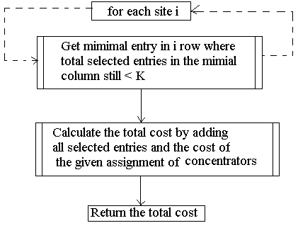

- The 2nd step in the pervious algorithm is obtained by:
- Initialize array Used[NumOfCon]← 0
- Get the minimal cost in the site row that achieve next condition
- If used[minimalcost column] < k and GetRight(WrongArray)=1 then
Store this selected entry as an entry in our solution
Else
Store this entry in WrongArray[]
Repeat step 2 ignoring all entries in WrongArray
- GetRight method is compare each entry in Wrong Array with the selected entry and return 1 if it not exist 0 other wise.

Sample runs:
    - let the input file sc.txt which contain the matrices of costs:

4 4 7 2 6
1 3 5 4 1
1 2 1 3 2
3 7 6 8 6
2 6 2 1 3
3 9 4 2 3
6 2 3 4 3
2 8 7 5 9

0 0 0 0 0
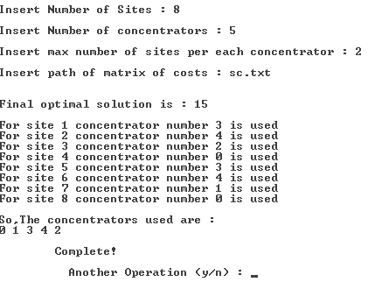

2 . If the file is :
4 4 7 2
1 3 5 7
1 2 1 4
3 7 6 8
2 6 2 7

2 3 5 7
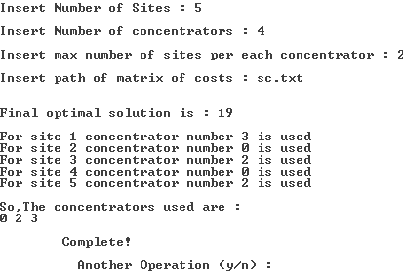

3 . If the file is :
2 3 7 2 6 2 4
1 3 5 6 2 1 3
1 2 1 4 3 5 6
6 3 6 8 2 4 5
2 6 2 7 2 5 5
2 3 5 2 2 5 5
2 5 7 8 2 2 7

2 3 5 7 1 3 5

The same result of pervious example will be in this example.

- If the file is

2 3 7 2 6 2 4
1 3 8 6 2 1 3
1 8 1 4 3 5 6
6 3 6 8 2 4 5
2 6 2 7 2 5 5
2 3 9 1 2 5 5
2 5 7 8 2 2 7

2 4 5 1 1 3 5

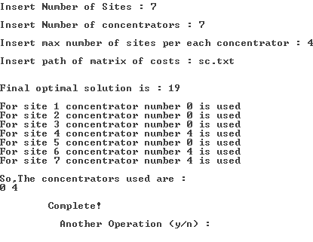
Here K = 4

COMPUTER ENGINEERING AND
SYSTEMS
FORTH YEAR

